Keith Gable
Introduction to Logic
Chapter 4

5. Hockey:
- Allow the audience to participate in fights.
- Sling more blood on the audience during fights
- Allow the audience to throw stuff at the people fighting
- Give the audience free beer.
- Allow the audience to vote on who wins
- Add an extra quarter where the audience plays eachother
- Add an extra quarter where the audience plays eachother without safety gear
- Randomly select an audience member each quarter to drive the zamboni
- Let audience members drive the zamboni during a game
- Sell mini blimps to spectators and let them fly them around with their own little advertisement or phrase.
- Melt the ice and let the hockey team play hockey on life rafts
- Melt the ice and let the audience play hockey on life rafts
- Melt the ice and let the audience play hockey on life rafts without safety equipment
- Lower ticket prices
- Pay people to come watch the games
- Give out useful free stuff at the doors
- Give out junk at the doors
- Give out jerseys
- Sell jerseys
- Give out autographs
- Sell autographs
- Give out free food
- When players get a personal foul, they have to do a line of cocaine
- Whenever a team gets a hat trick, the spectators have to chug a beer
- Whenever a team gets a hat trick, the spectators have to do a beer bong
- Let audience members purchase tickets for a halftime zamboni race that they participate in
- Audience members can override referees by a 2/3 vote.
- Increase restroom capacity
- Increase drink output
- Let the audience “adopt a player” – let them tell the player what to do if they pay a certain amount.
- Every time a player gets a personal foul, they have to do a shot
- Every time a player gets a personal foul, the audience has to do a shot
- Make the hockey players play with blindfolds on
- Let the audience members play other sports at the hockey game
- Make the games less violent so more people bring their children
- Have a kids rink
- Have kids teams
- Bring in two sports: arena football and ice hockey – on the same rink
- Have matches all year round
- Hire Sony's marketing department to make people think that they need to show up to a hockey game to be cool
- Hire Microsoft's marketing department to make people think that they need to go to a hockey game or else they die
- Free kids admission
- Free daycare
- Free hockey puck
- Allow people to sit anywhere
- Hand out souvenirs
- Hire someone from George Orwell's Nineteen Eighty-Four's Ministry of Truth to convince people that other sports do not exist
- Buy out all other sports and force them to play hockey
- Hire a lobbyist to get a constitutional ban on other sports
- Buy a President and have him speak against other sports

13. Computers in 2017:
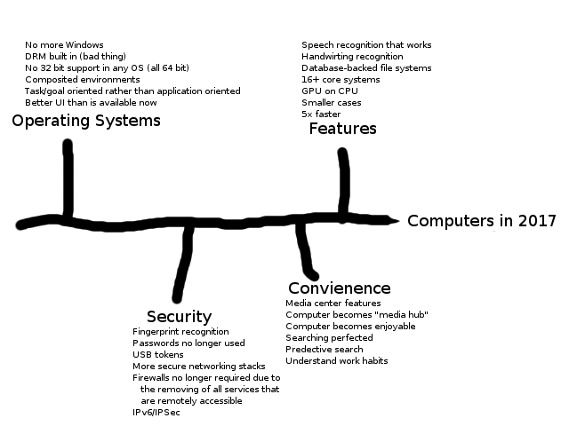

17. Visualizing stuff
a. A telephone call in 2010

Support Rep: Thank you for calling Earthlink, my name is Habeeb, how may I serve you today?
Customer: Yeah, my them there Internet tubes are clogged. Nothin's happenin' when I try to click the “e”.
SR: Sir, is your computer on?
C: What'dya think I am, stupid? 'Crse it's on!
SR: Alright den, can you click on the blue “e” on the desktop please?
C: Din't you hear me, I said it dun't work!
SR: Ah. I see. What exactly do it do?
C: Nothin' happens.
SR: Well, have you tried reinstalling Windows?
C: Do-wha?
SR: Yes. You may need to reinstall Windows to repair Internet Explorer since this looks like a corrupted IE. I can't help you with dis, but a local computer shop might.
C: It was working a few days ago.
SR: Sir, there is nothing more I can do for you. Thank you for calling Earthlink and have a nice day.

b. Eating a meal in 2050
Assuming I make it that far, eating a meal in 2050 would probably be like in Back to the Future Part II. Pizza Hut pizzas go in the hydrator as tiny bitty things and come out as big pizzas. Basically just like our current microwaves. Other than the possibility of new appliances and home features, I think it will be much the same as it is now.

c. A homework assignment in the year 2025
I have to assume this will be college level work. And for the sake of example, I'll say it's English. The work will get easier due to the fact that parents aren't pushing their children to do good in school anymore. I think that Freshman Composition I will be teaching basic grammar and sentence structure rather than essay mechanics, and that Freshman Composition II will be the current Freshman Composition I.

d. A homework assignment in the year 2125
Also assuming English class at college. In 2125, we will have hopefully accepted the theorem of natural selection, and will have eradicated the idiots forming the moron chain that plagued the homework assignment in 2025. I expect that in 2125, English homework will be harder, because the language will have changed so much over the years. But all of the basic stuff they currently teach in Freshman Composition I will be taught in grade school.

